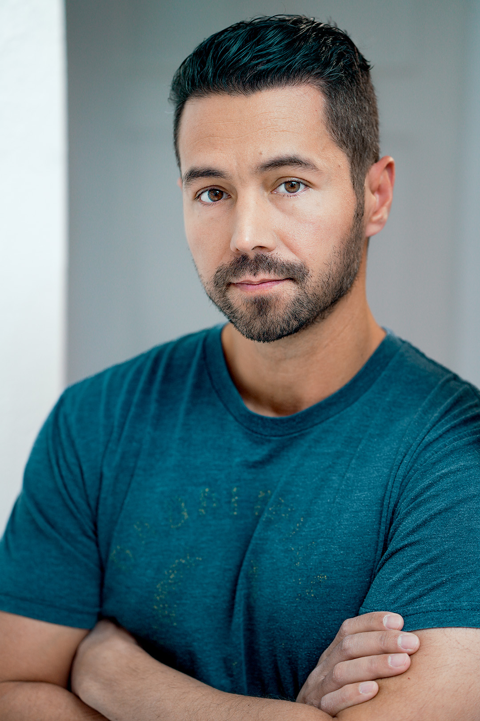

ERIC MARTINEZ
Evergreen, CO | martinez.ericw@gmail.com | IMDb: https://imdb.me/ericmartinez

BIO
Eric Martinez was born and raised in New Jersey. After graduating from Princeton University, he settled with his family in the mountain town of Evergreen, Colorado. A lifelong creative, Eric has rediscovered his passion for acting and performance. He is the owner of Java Groove Café and an advocate for human connection and community.

FILM
- Martha’s Notebook: Samuel and Jordan | Dereck | Short Film (Post-Production) | 2025 | Dirs. Curt Fulster and AJ Bennett
- Running | Derek | Short Film (Post-Production) | 2025 | Dir. Tim Kernc
- I Got a Song – The Story of Sugarloaf | Aaron Raymond | Feature Film (Post-Production) | 2025 | Dir. Stacy Raymond & Kyle Lamar
- Mocha & Mistletoe | Sam | Feature Film (Post-Production) | 2024 | Dir. Candice T. Cain

TELEVISION / TV MOVIES
- Heavy Hitters s2 | Raphael Robles | TV Series (Post-Production) | 2025 | Dir, Candice T Cain
- The Wedding Belle | Jared Bruckner | TV Movie (Post-Production) | 2024 | Dir. Candice T. Cain
- Humbug the Elf | Greg | TV Movie (Post-Production) | 2024 | Dir. Candice T. Cain
- Heavy Hitters | Creative Producer | TV Series (Post-Production) | 2024 | Dir. Candice T. Cain

COMMERCIAL
- Furniture Row | Husband | Commercial | 2025 | Dir. Bret Bertholf
- Corwin Auto Group | Dad | Commercial | 2025 | Dir. Tye Lombardi
- HydraPak | Hiker | Commercial | 2025 | Prod. Maureen McCauley

NEW MEDIA
- Sword and Scale – ep. Kara Nichols | FBI Agent | Podcast True Crime Reenactment | 2025 | Dir. Ash Patino / Sword and Scale
- Sword and Scale – ep. Alicia Martinez | FBI Agent | Podcast True Crime Reenactment | 2025 | Dir. Ash Patino / Sword and Scale
- Talia Holt | Boyfriend | Music Video | 2025 | Dir. Kyle Lamar

TRAINING & EDUCATION
- Bachelor's Degree – Princeton University

SPECIAL SKILLS
- Athletic (Baseball, various sports)
- TaeKwonDo – Red Belt
- Driver’s License
- US Passport
- Basic Spanish

