Bella Romero

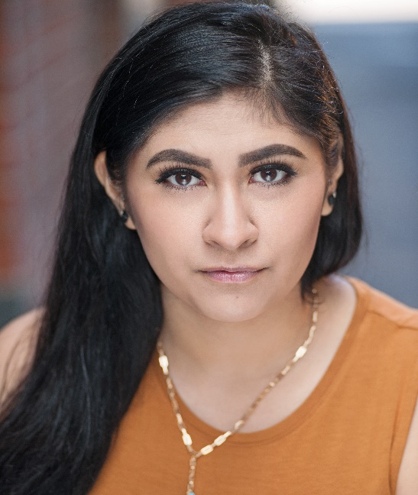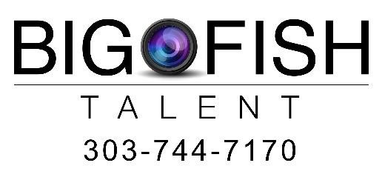

Eyes: Brown
Age Range: 18-29

Portrayable Ethnicities:
Latin American (Mexican, Ecuadorian, Chilean, Colombian), Puerto Rican, Brazilian, Portuguese, Middle Eastern, Native American, Italian, New Zealander, Egyptian.

Film:
Dichotomy Lead Dir. Nina Buchanan
A Misfit Christmas Lead Dir. Meghan Charton
Dying With You Lead Dir. Zohar Heiman
Down the Drain Lead Dir. Rion Smith

Professional Training/Education:
B&B Acting Classes Ronda Belser
The Actors Tune Up Marty Lindsey
Actors Tune Up Kathryn Brink
Emotional Access Marilyn McIntyre
Zoom “Self Taping” Class Hamilton Casting
Crying on Cue Howard Fine
Using Your Imagination to Find the Truth Marilyn McIntyre
8-Steps Lecture Howard Fine

Special Skills:
Languages – English (fluent), Spanish (fluent), French (conversational), Italian (beginner), German (beginner)
Accents – Spanish, German, Russian, Italian, Southern
Recreational – Weight lifting, Running (long distances), Running (sprint), Dance (modern day), Jump Rope, Hula Hoop, Basketball, Bowling, Soccer, Yoga, Krav Maga (beginner/basic)
Vocal – Choir (6 years)

