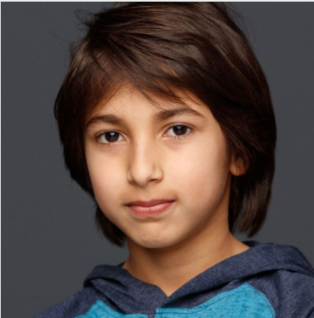
Avi Khanna

Parent Contact:dkhanna01@gmail.com 303-557-8186

THEATRE
Theater Class PACE (Parker Arts, Culture & Events Center), Parker CO

FILM & TELEVISION
None

TRAINING
Level 1: Scenes & Monologues Wilbur Currie, Fayth Krause Colorado School of Acting
CSA Company: Self Mgt Elizabeth Karsell Horne Colorado School of Acting

SPECIAL SKILLS
Languages: American English, Hindi
Music: Piano (Beginner)
Dance: Free Style
Sports: Soccer, Karate (1 year), Football, Swimming
Other: Art

